To implement this project we have trained CNN with more than 500 COVID and NORMAL chest X-Ray images. We have used below dataset to trained CNN model

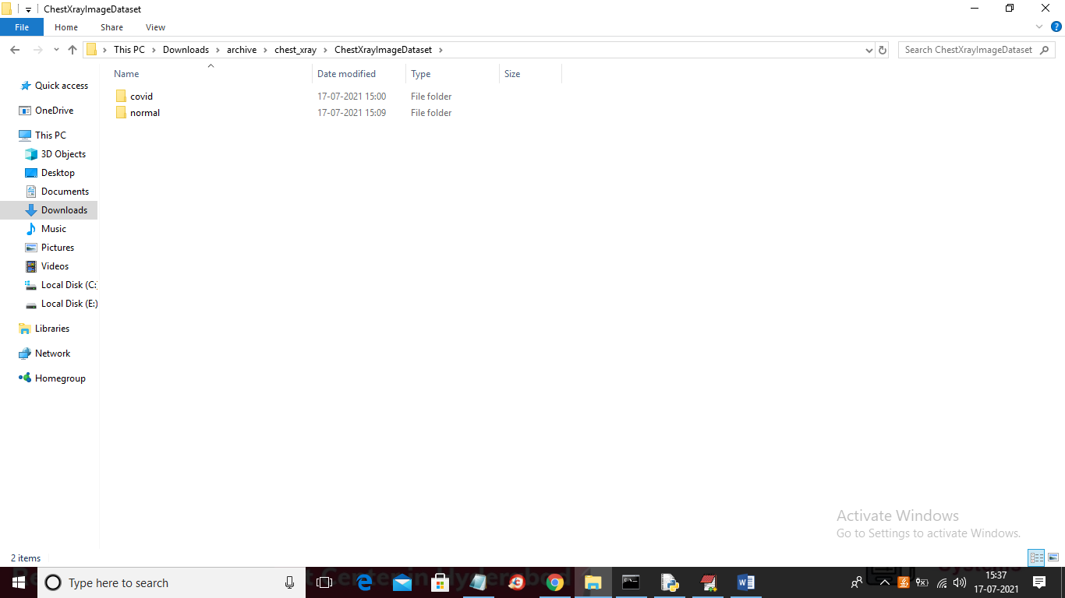

In above screen we have two folders where one folder contains COVID X-Ray images and other folder contains normal images and just go inside any folder to see images like below screen

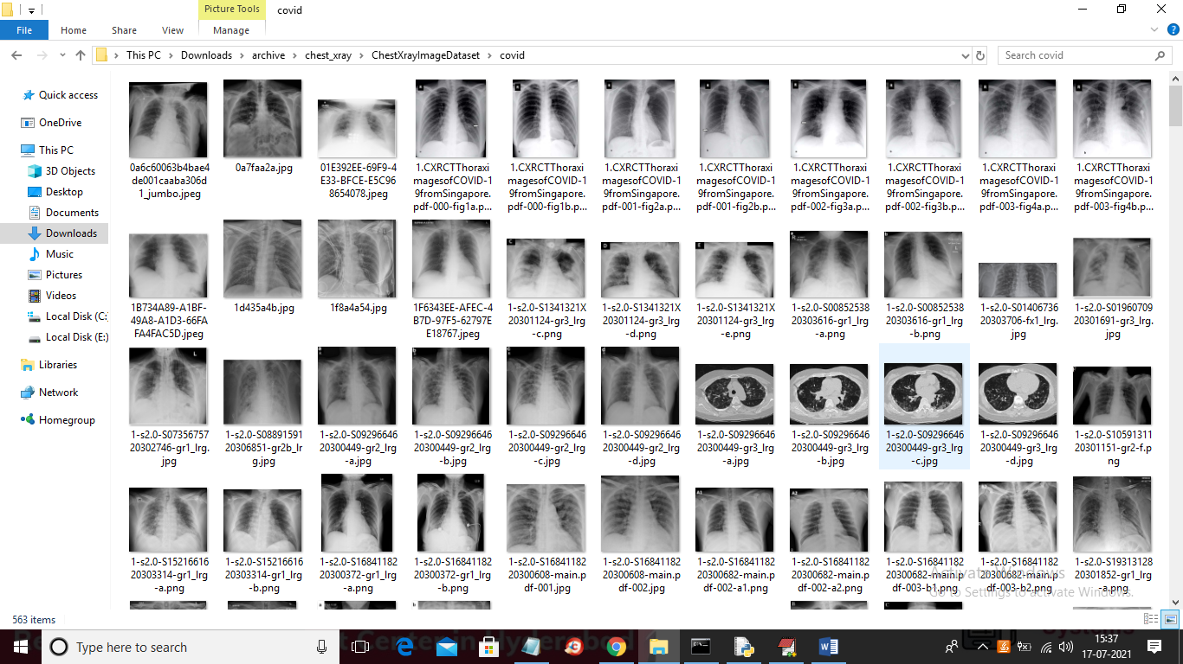

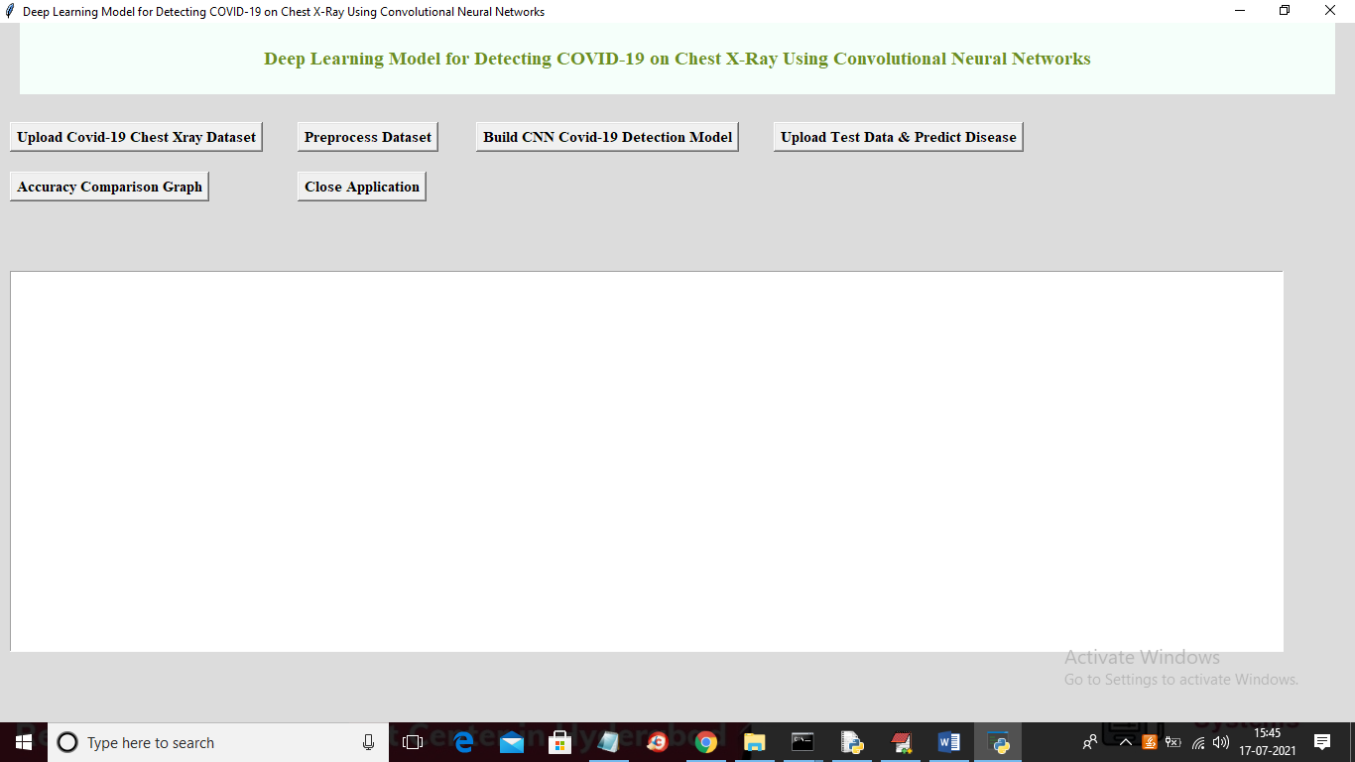

In above screen click on ‘Upload Covid-19 Chest Xray Dataset’ button to upload dataset

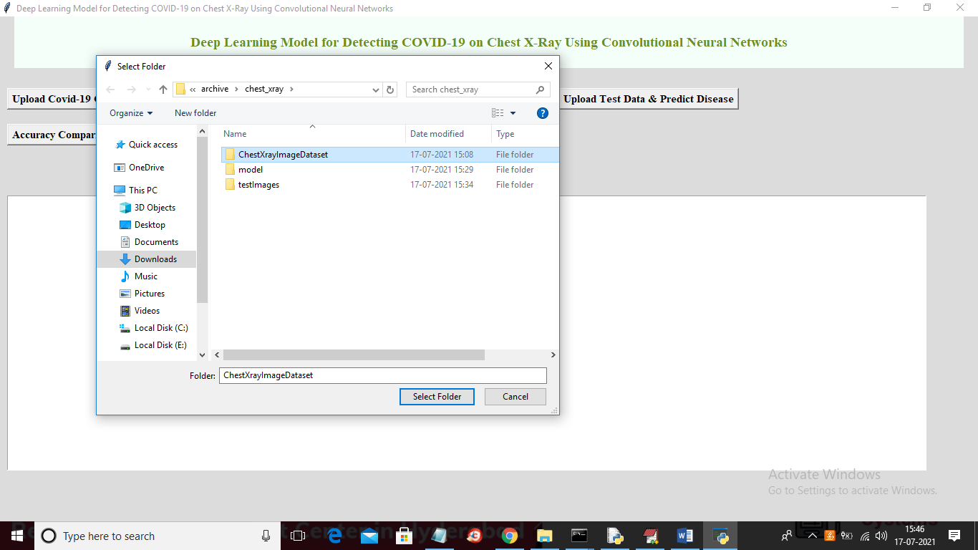

In above screen selecting and uploading entire ‘ChestXrayImageDataset’ folder and then click on ‘Select Folder’ button to load dataset and to get below screen

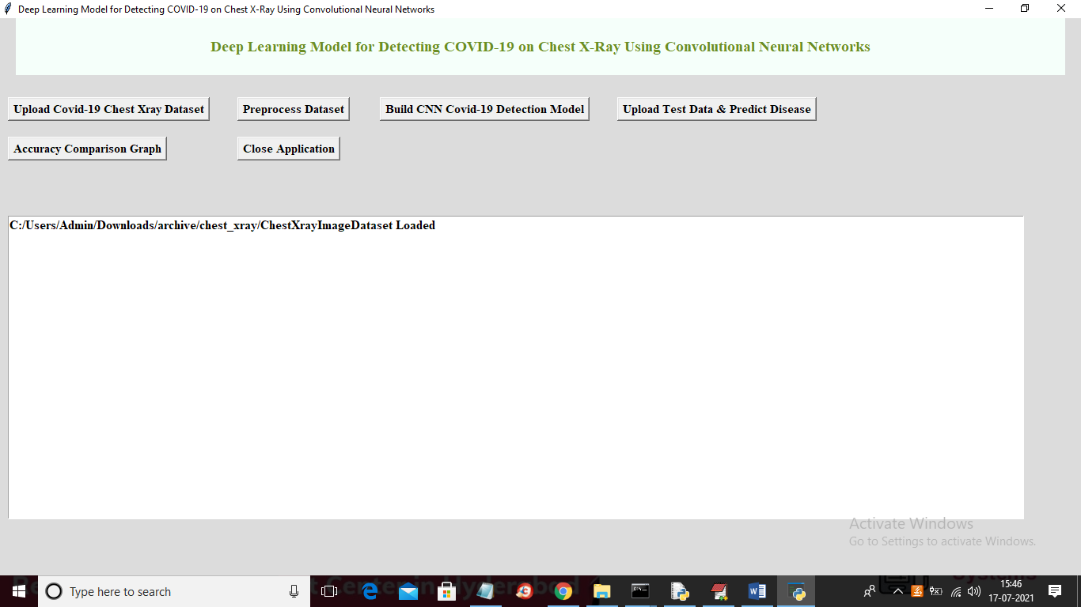

In above screen dataset loaded and now click on ‘Preprocess Dataset’ button to read and process images

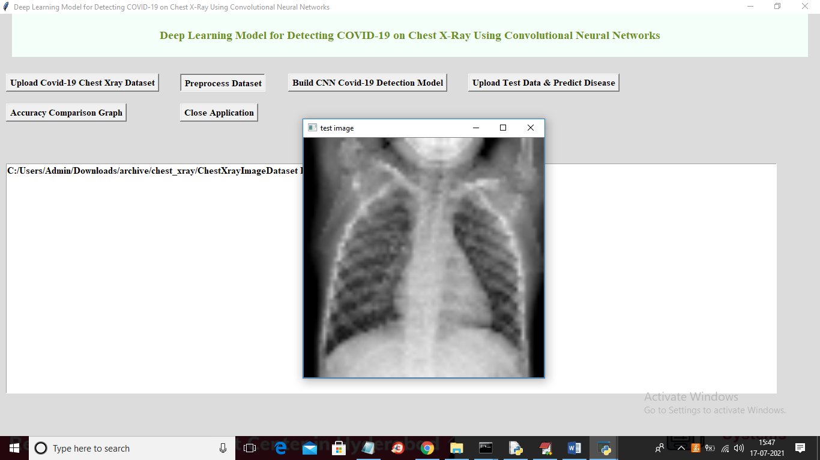

In above screen after preprocessing I am displaying one image to check whether image are loaded properly or not and now close above image to get below screen

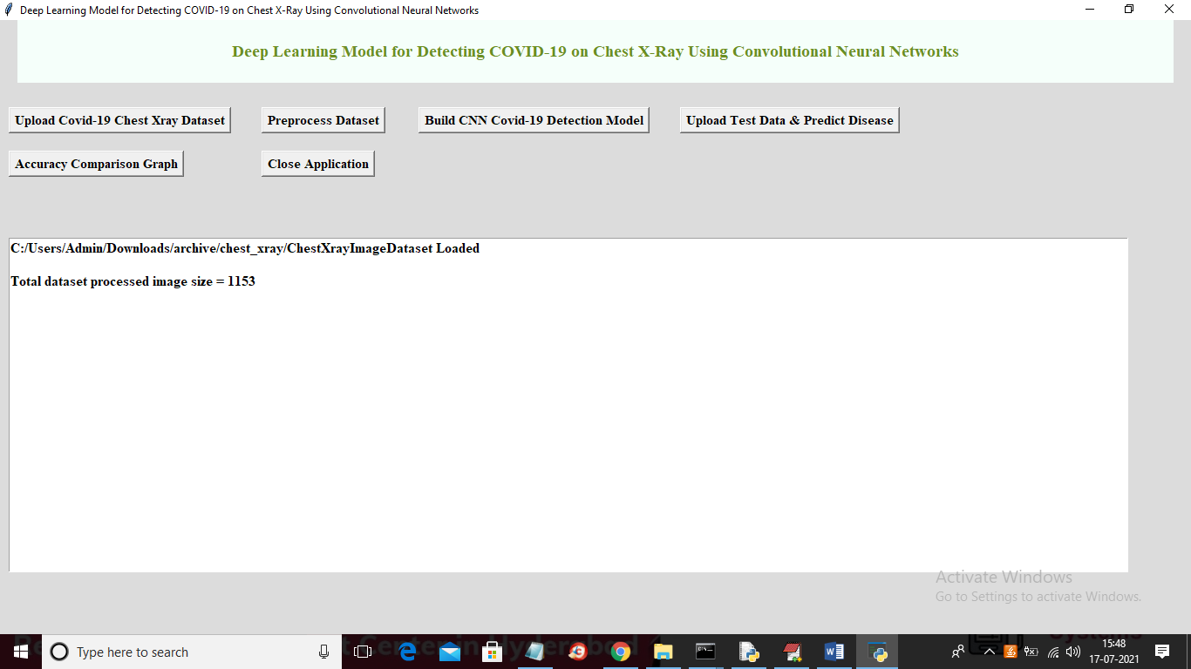

In above screen application found total 1153 images and all images are processed and loaded for training and now dataset is ready for training and now click on ‘Build CNN Covid-19 Detection Model’ button to start training CNN with above dataset and to get below screen

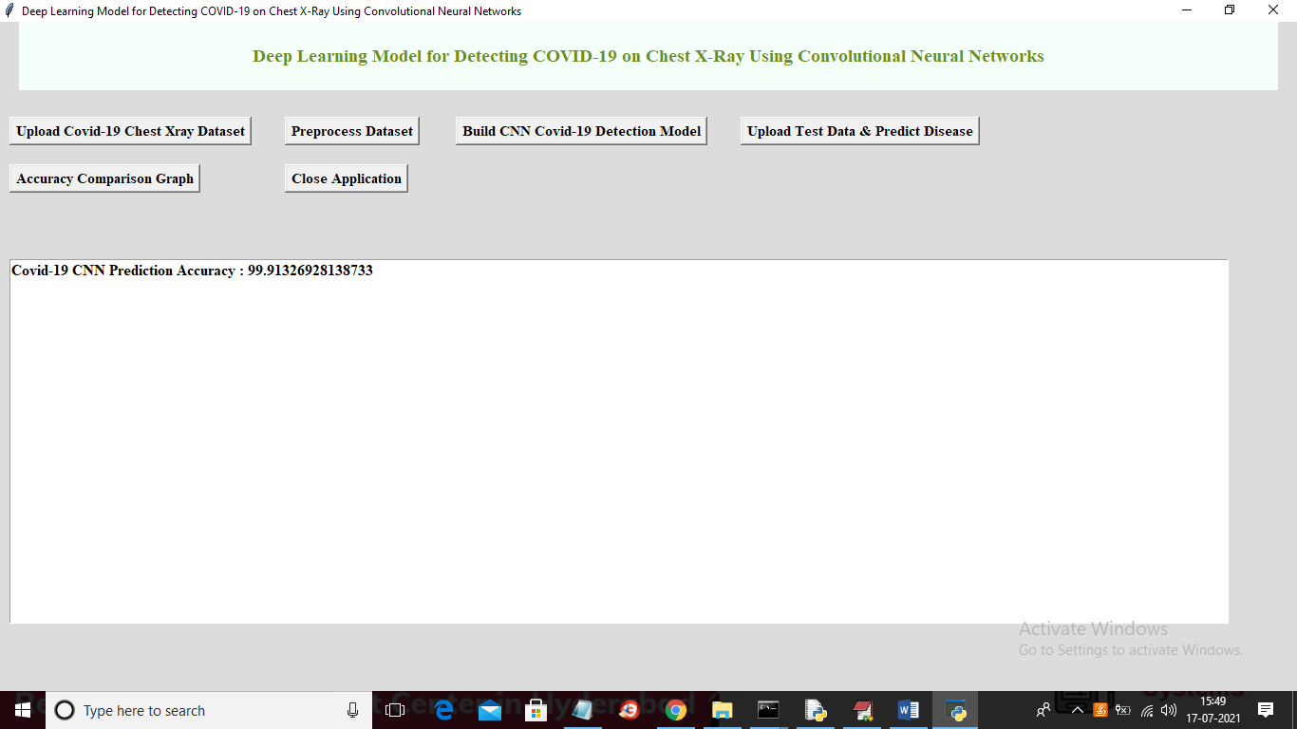

In above screen CNN model is trained and we got its accuracy as 99.91% and now CNN model is ready and now click on ‘Upload Test Data & Predict Disease’ button to upload test image and then predict disease

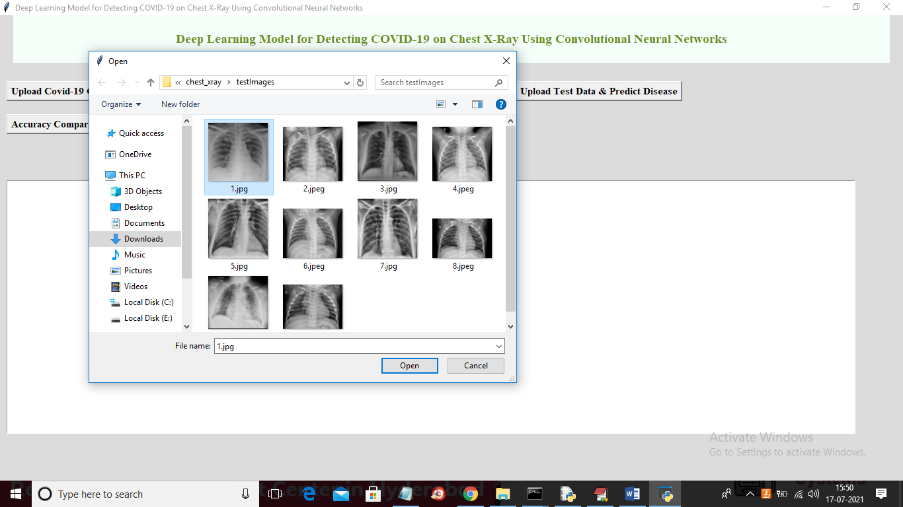

In above screen selecting and uploading ‘1.jpg’ image and then click on ‘Open’ button to get below prediction result

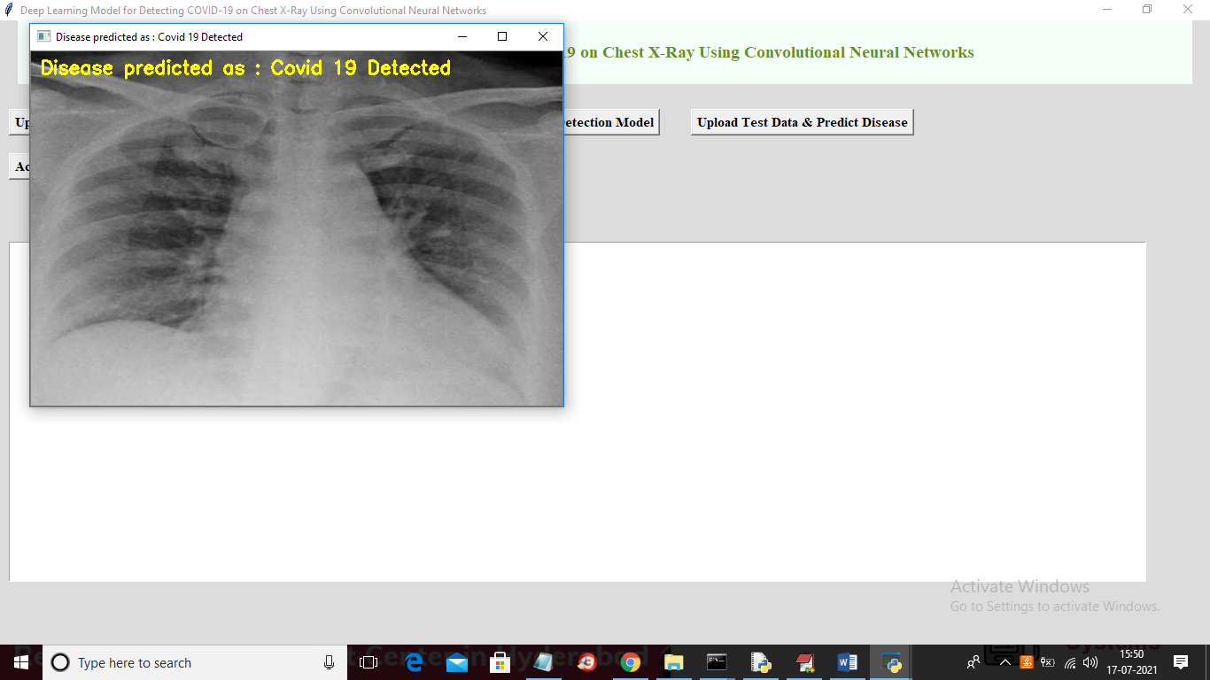

In above screen image in yellow colour text we can see uploaded chest X-Ray predicted as Covid-19 disease and now test with other images

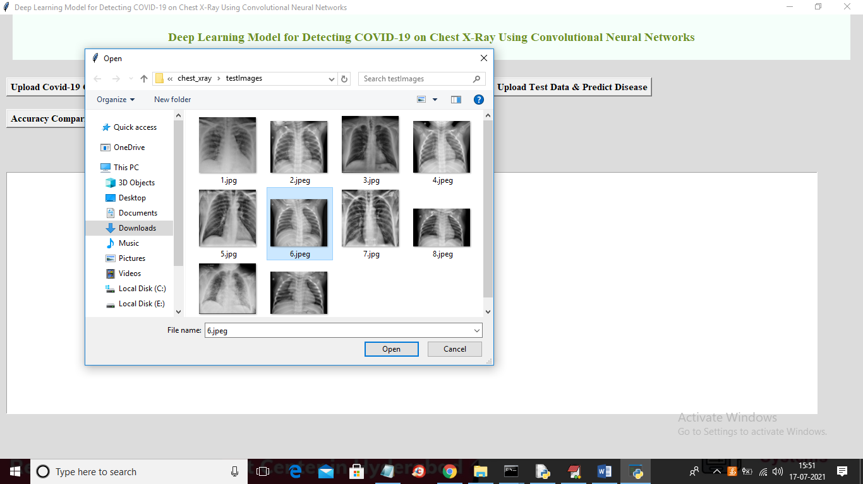

In above screen uploading ‘6.jpeg’ image and now click ‘Open’ button to get below result

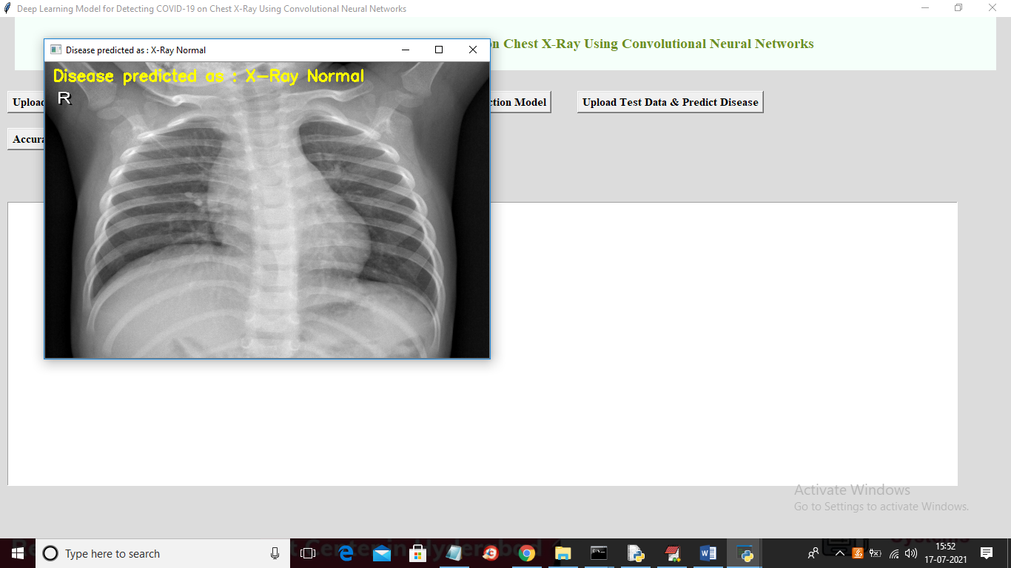

In above image X-Ray is predicted as Normal. Similarly you can upload other images and test them and now click on ‘Accuracy Comparison Graph’ to get below result